
Blue Team Shooting Sports A.S.S.S. April 28th. 2026
COURSE DESIGNER: DelMarVa 2026

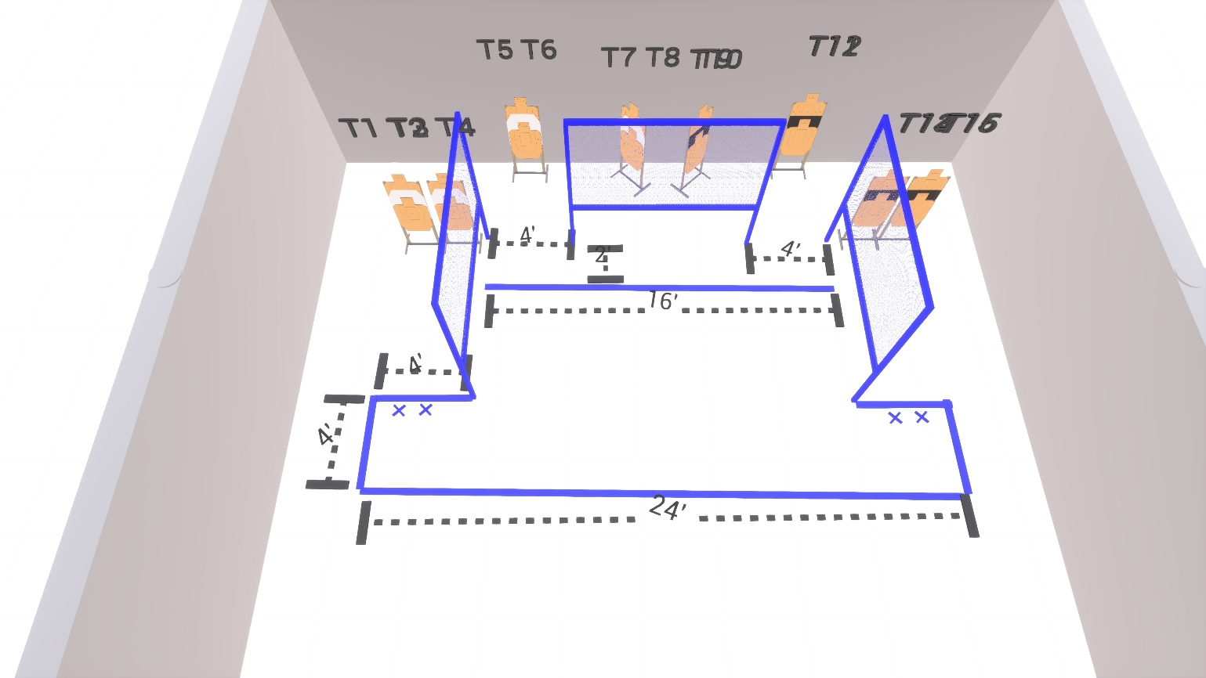

Written Stage Briefings:

Stage 3 – I'm useless, but not for long - is a 32-round, 160 point, Comstock Course. There are 16 cardboard targets. The best 2 hits per cardboard target will be scored.
Handgun start position Feet on Xs. The handgun is loaded and holstered, wrists below belt.
PCC start position Feet on Xs. PCC is loaded, held in both hands, with stock touching belt.
On the audible start signal, engage targets as available from within the shooting area.

